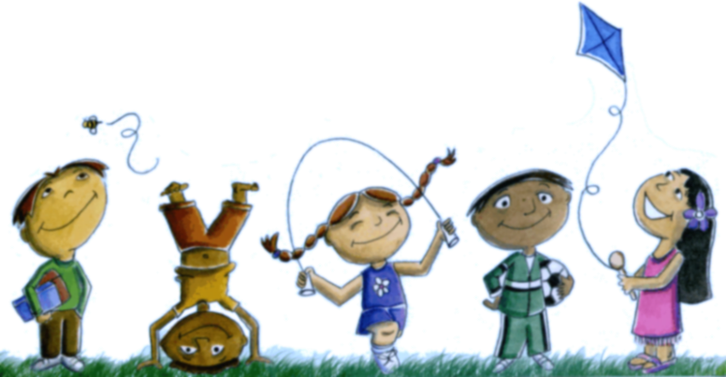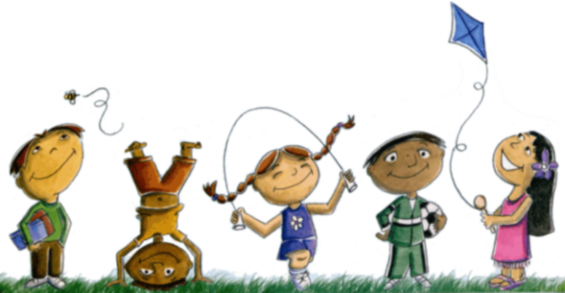
Welcome Back
Oak Meadow 2018-2019
In summer, every day is a holiday! What about school? You can’t always sit at home! Well, in my opinion, I don’t miss holidays. What I am excited about at school is the reading fair. Of course, I’m a bit nervous about speaking to the audience, but I will try to do my best on my project. I wish you good luck too!  - Alesya  I went to the United Kingdom for my summer school, and I will miss my friends and teachers as well as the places and people there.  - Chompoo  I’m going to miss the freedom to be entertained. I will also miss the happiness of sunny days. I will miss feeling like a kid. - MJ | I will miss waking up when I want and staying up late. In summer I can spend the day doing what I want and going out often.  I am excited for the next holiday and getting closer to grade 10, which mans I will get closer to university and become ready for a whole life of work.  - Vlad  I think that our vacation is short. This school year I want to make new friends, study harder, and read some new books .  - Selina  I will miss going to the beach, Italy, and waking up late in the morning.  - Francesco  I’m going to miss waking up any time I wanted. This school year, I would like to find new friends and learn to study better.  - Diana  Students say, “Goodbye Summer!”

My name is Faria Griffiths, and I am from Suffolk, England. I teach English at Oak Meadow for grades 2-5. I have been teaching at Oak Meadow for a year and a half now, and it’s been a pleasure to be a part of this school. To me, the best thing about being a teacher is seeing a student’s face light up when they finally get a concept.

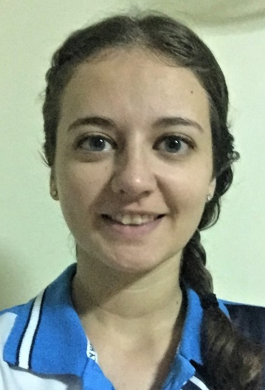
Hello everyone. My name is Bethany Sluus. I am from New York State in America. I am the Middle and High School English teacher for Oak Meadow International School. I have been working here since January, and I love exploring Phuket, when it’s not raining. My favorite color is blue, and I really enjoy eating apple pie. This year, I look forward to watching and helping the students grow more confident in their reading and grammar skills.
Welcome back!!
It is a pleasure to be a part of Oak Meadow International School’s teaching force, especially for Middle and High School. My name is Moriel Andres, and I teach Biology and Social Studies. I come from the northernmost part of the Philippines. I have enjoyed the fruits, scenic views, and friendly people in Thailand for more than eight years now! I love being with young people too! We will definitely have a great fun learning this year.
Welcome back!!
Oak Meadow Teacher Spotlight
August 2018
National
Friendship
Month
Kaylynn-
Friends mean a lot to me. My first friend is when I was two. Her name was Millie, she meant a lot to me because she would share secrets. When we got into a fight, two minutes later, we were friends again. She was always my friend. Since I moved to Oak Meadow, I don't see her as much as before, but I have a lot of friends here too.
She never lied to me. She was always honest with me.

Federica-
Friendship is my life. If I don't have friends, my life is nothing to me. I love my friends because we play together every day. I tell secrets to my BFF. We help each other when we are hurt. When we're sad, we try to make each other happy.

Celi-
Friendship means to be honest with each other, to play and hang out together. Friendship is strong. They can make us calm and joyful.

Helena-
To me, friendship is about honestly because you know your true friends will never be mad with you. They love you and they want you to be happy. They want to be closer by helping and working with you. After all, that's what friends are for!

Igor-
Friendship means love, having a good time, happiness and also you can play all the games with your friends. My best friend is Sava because he comes to my home and we play together, we ride bikes together.

T.K-
To me, friendship means that we would always be friends forever!! I only have two friends. The first is Austin and the second one is Dominik. In the future we will go travelling around the world together. We would never break our love. If we are so tired we would always help each other.

Sayo-
Friends are my life. I do everything with them. Sleepovers, play dates, all that kind of things. I can never laugh all the time without my friends, they mean so much to me. We also study together. There are plenty of things to do together. To me, if I don't have any friends, I would not laugh or play every day. Friends are amazing!

Queen Sirikit’s Birthday Thai Mother’s Day
August 12
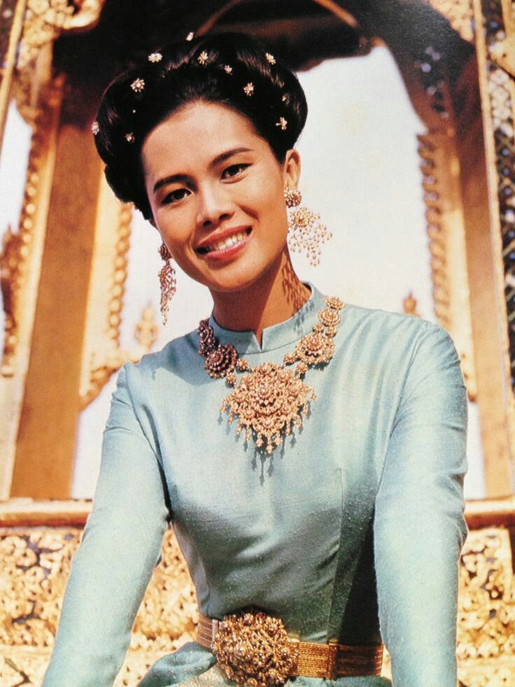
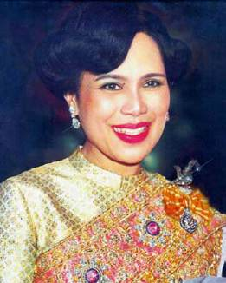

HM Queen Sirikit was born on August 12, 1932. This year marked her 83rd birthday. August 12th is also Mother’s Day in Thailand. This is no mere coincidence. Mother’s Day was first introduced to Thailand on April 15, 1950 shortly before the marriage of HM Queen Sirikit. Twenty-six years later in 1976, Mother’s Day was moved to coincide with Queen Sirikit’s birthday because the queen is known as Mother to the Thai people. She is beloved for her many actions taken on behalf of the Thai people. She is known as being a quiet diplomat, epitomized by the respect shown her by the Muslim minority for promoting peace, tolerance, and understanding in an attempt to bring harmony and happiness to all her people. HM Queen Sirikit is also a mother to one son and three daughters.
In Thailand, the preparations for HM Queen Sirikit’s birthday and Mother’s Day begin weeks in advance. People all around the country raise national flags and blue flags, the flag of the queen. Blue and white ribbons decorate the roadways and houses and signs are decorated with the portrait of Her Majesty the Queen. This is the way in which Thai people express their loyalty to and honor for the queen. In Bangkok, Ratchadamnoen Avenue and Sanam Luang, the area around the Grand Palace, is bedecked with colorful lights and a fireworks display is an added attraction.
Thai people also use this day to celebrate mothers. Mother’s Day morning in Thailand starts by giving alms to the monks. Following Thai tradition, kids kneel down before their mother to show their love and gratitude. They present her with white jasmine flowers or garlands and in return, mothers give their blessings to the children. On this day, white jasmine flowers are a common sight in Thailand as they are a symbol of maternal love. The white color of the flower symbolizes purity of a mother’s true love, which will never change. Charitable activities, donations, and offerings to monks are also an important part of the day to express child’s love and gratitude towards mother.

Kindergarten & Nursery
Holidays are over and this time classes starts again. Students are all excited to be back in school and all are eager to see their classmates and teachers. This school year the students have a new recreation area that will surely be one of their favorite spots in school. The first day of school was full of happy faces as the students saw their new playground. Our little learners can’t keep their eyes off of the new playing field and were excited to play on it right away.
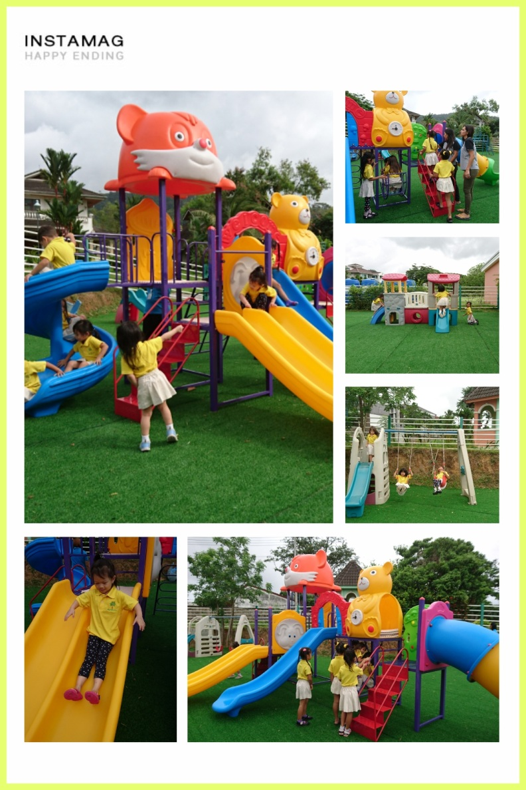

The School started with our very own Kindergarten assembly in Teacher Jane’s classroom. Everyone was gathered and a new teacher was introduced and everybody welcomed Teacher Emilie. Teacher Emilie will be monitoring K1 and K2 Literacy subjects.

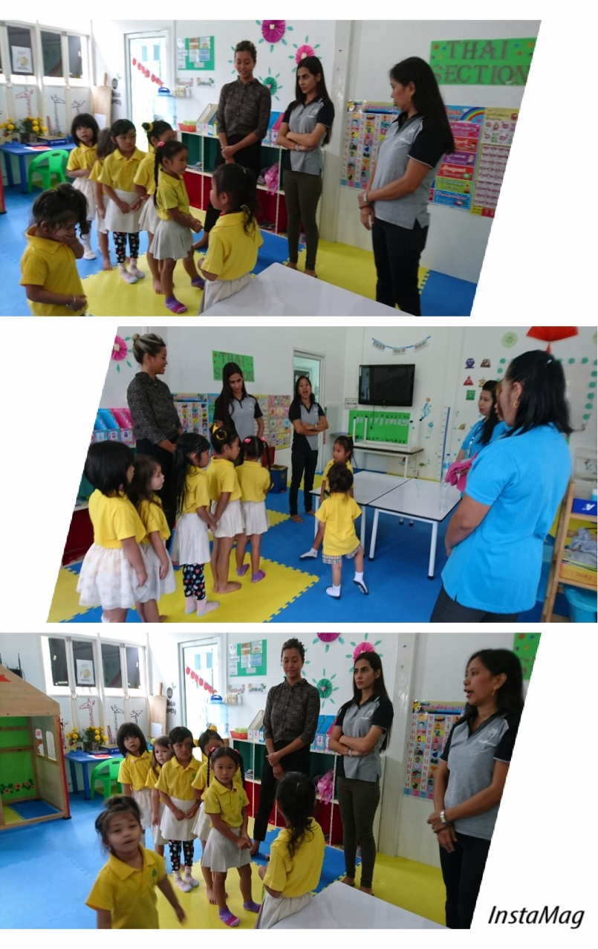

This Academic year 2018-2019,
The Kindergarten Department created
a theme and named each month of this
School year as “ Kindergarten’s Twelve Months of Beings” wherein each months
will be as follows.

August as Being a Caring friend September as Being Independent October as Being Polite and Respectful November as Being Healthy and Hygienic December as Being Generous and Kind January as Being Creative
February as Being Grateful
March as Being Brilliant
April as Being Perseverant
May as Being Lovable
June as Being Positive
July as Being Happy
Every month students will be taught,
practice, and accomplish the ‘’Beings’’
assigned for that designated month.

For this month’s theme, kindergarten students learned the first “Being” for this month, called “Being a Caring Friend”. The students have started showing and practicing what it means to be a good friend. They do this by showing love and care, not only for their fellow students and teachers, but also for their surroundings. Each student has brought their own plant, and every day they take time to water and take the weeds off of their plants. It is also a one way to teach the students how to be responsible and show concern for our environment.
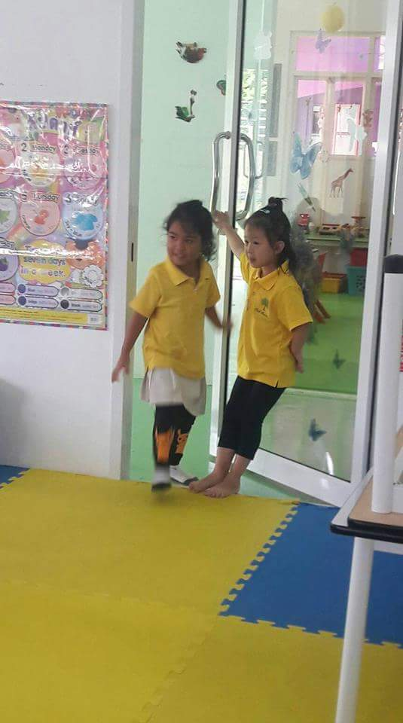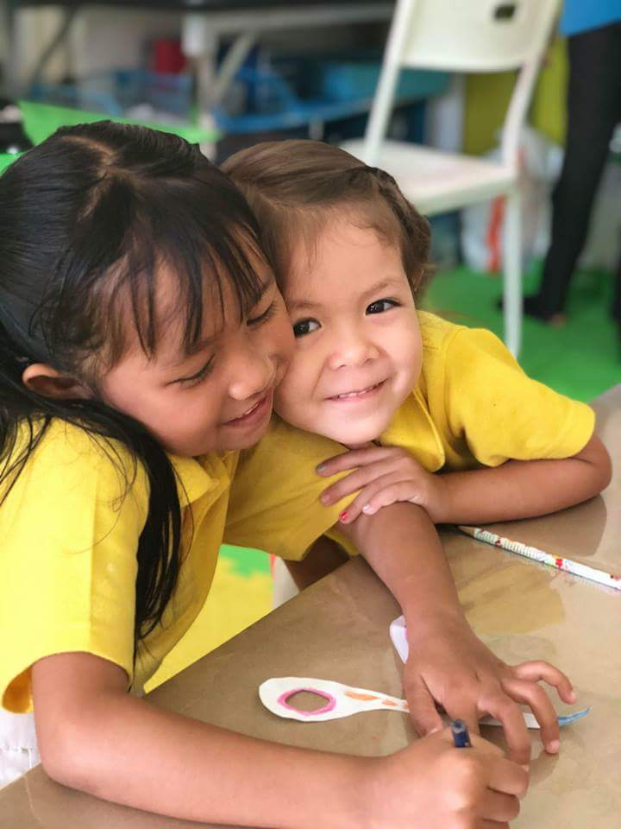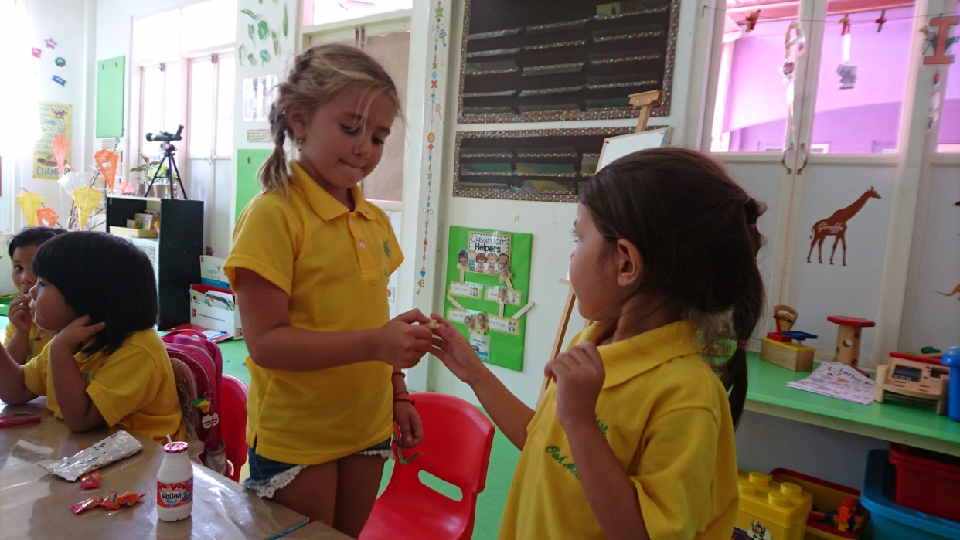

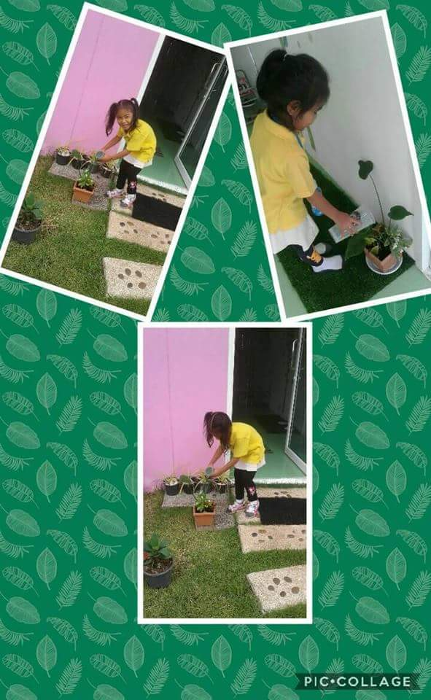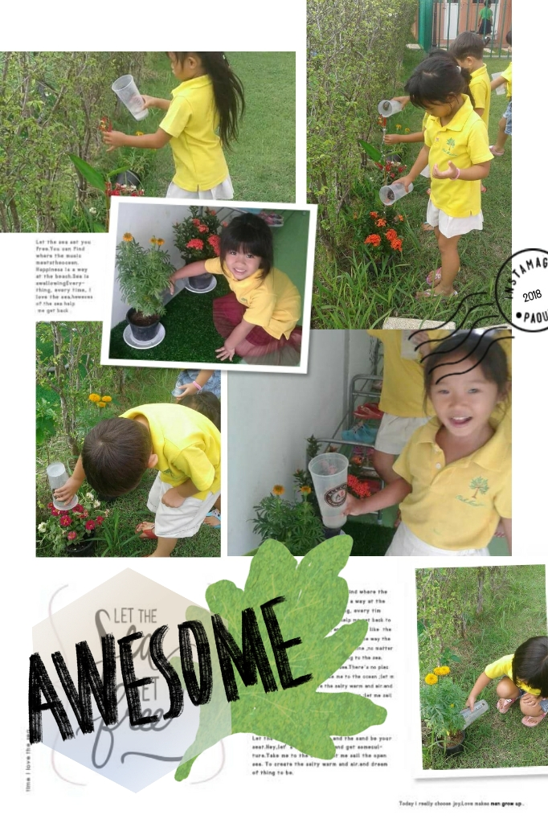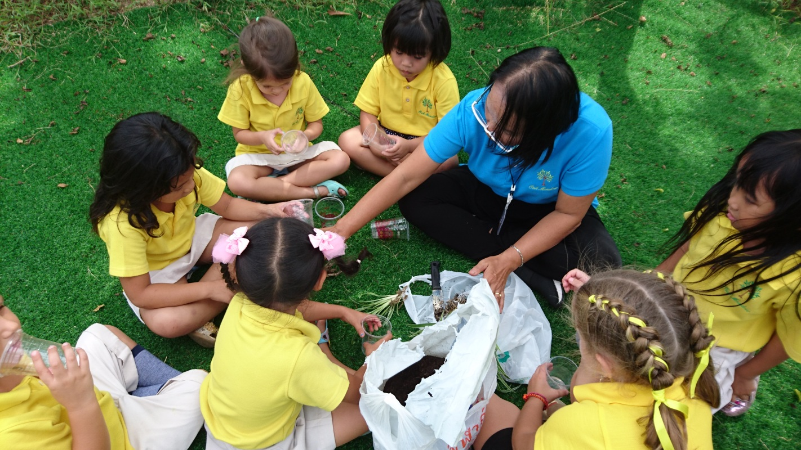
Nursery Grade 1 Grade 5 Grade 9
Sam Emily Ann MJ
K1 Grade 2 Grade 6 Grade 10/11
Jaesol Milana William Jake
K2 Grade 3 Grade 7
Mena and Si Woo Adam Alesya
K3 Grade 4 Grade 8
Kaimook and Naomi Federica Max
Class Dojo Leaders
This Photo by Unknown Author is licensed under CC BY-NC-SA
This Photo by Unknown Author is licensed under CC BY-NC-SA

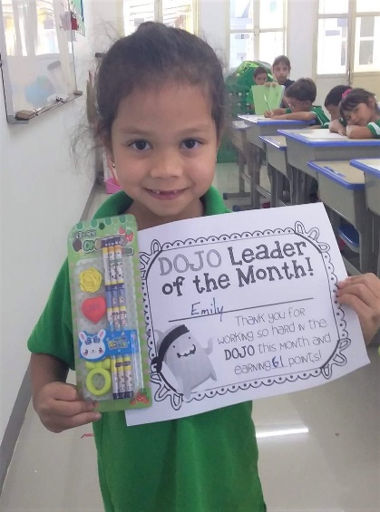
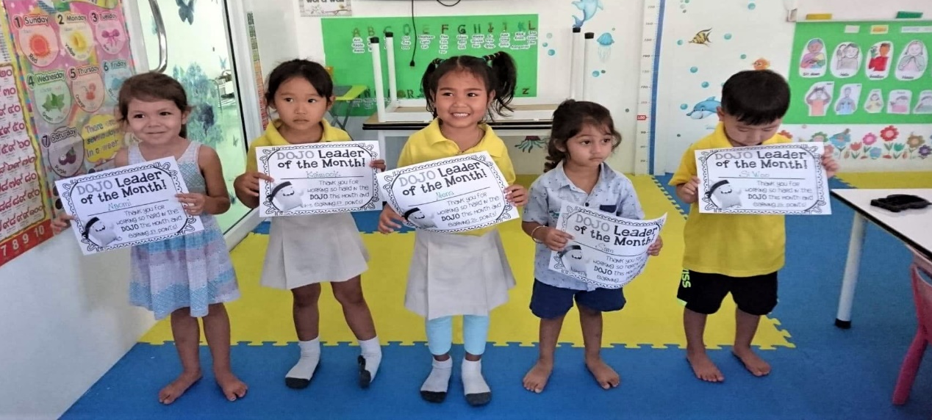

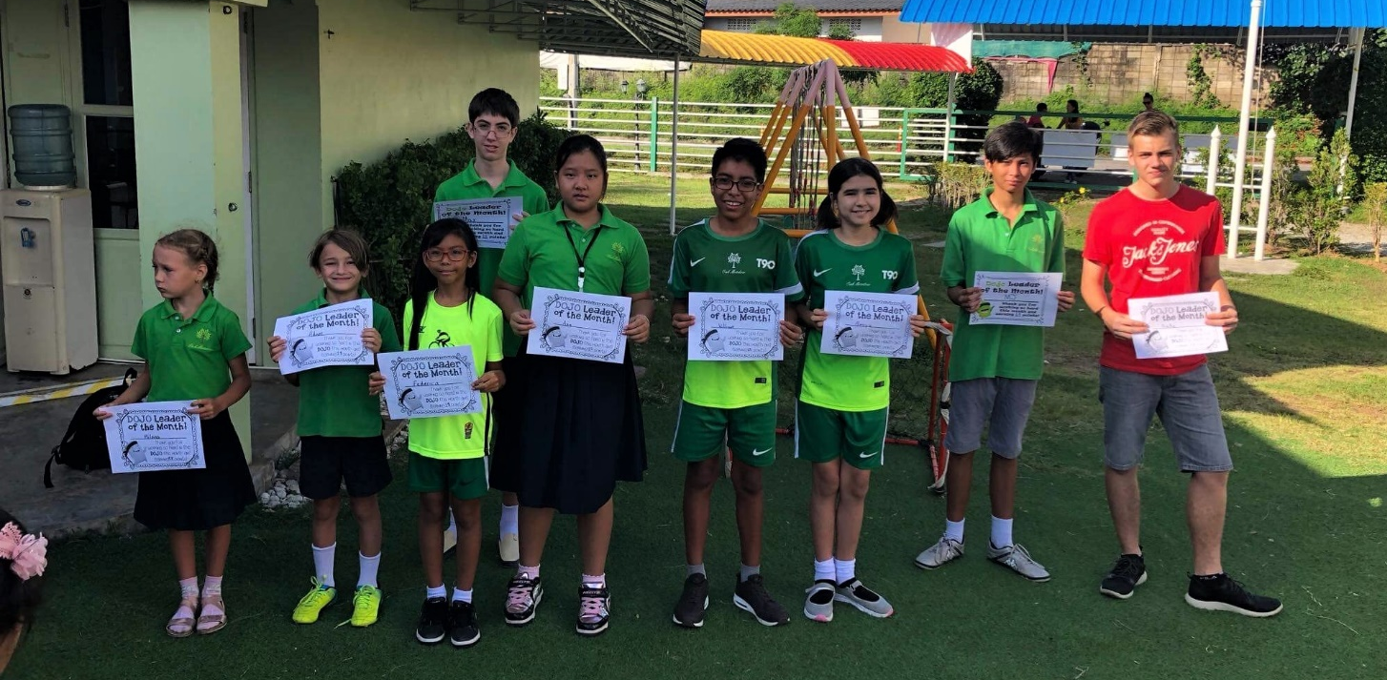

Student Accomplishments
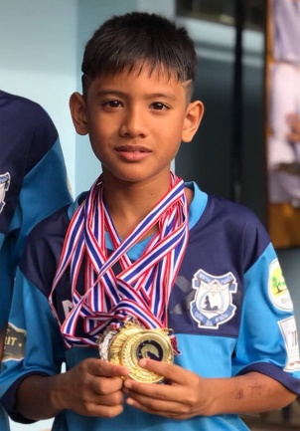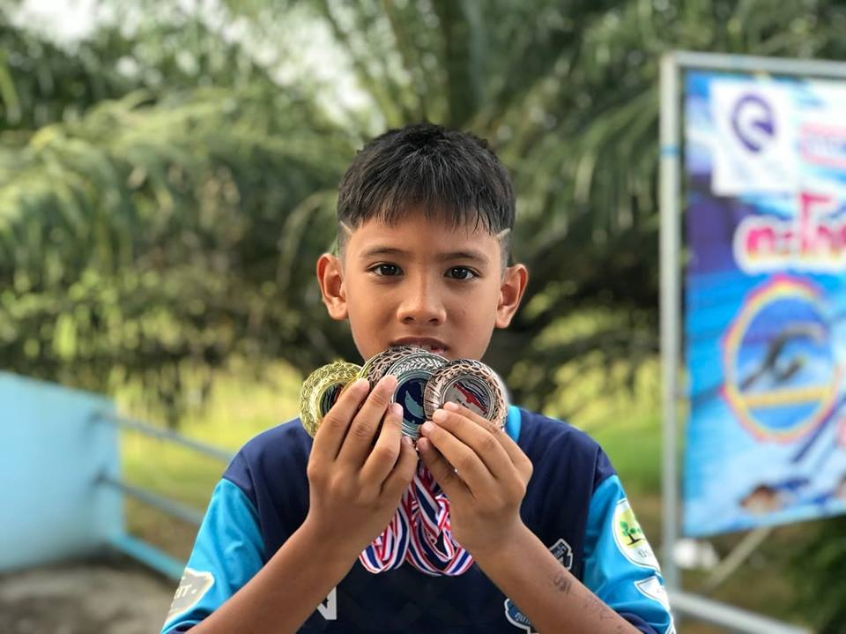
Congratulations to OM for winning 7 medals in a swimming competition held in PhangNga over the summer holidays. In the category of male 9 years old, OM won the gold medal for the Freestyle 100 meter, Breaststroke 100 meter and 50 meter, silver medal for the Freestyle 50 meter race, and the bronze medal for Backstroke 50 meters, Butterfly 50 meters, and 4x 50 meters Freestlye.

